 | 10.3.2 Editors - Compositor Editor - Sidebar - Tool Tab
Table of content
Tool Tab 1

Tool Tab

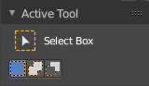
The settings of the currently active tool in the tool shelf.
In the node editor we don't have something special here. The tool related settings are explained in the tool shelf chapter.

